Ideation Phase
Define the Problem Statements

Date | 30 September 2026
Team ID | SWTID-2026-6249
Project Name | AI FAQ Assistant API
Maximum Marks | 2 Marks

Customer Problem Statement:
The AI FAQ Assistant API uses brainstorming and idea prioritization to identify effective solutions for customer problems. During brainstorming, the team gathers common customer questions, complaints, difficulties, and feedback from different sources. These ideas are grouped into categories such as product issues, technical support, payments, and general queries. After collecting ideas, they are prioritized based on customer impact, frequency, urgency, and implementation effort. High-priority problems are addressed first to improve customer satisfaction and reduce response time. The AI FAQ Assistant API then uses these prioritized ideas to create relevant, accurate, and easily accessible answers for customers through an automated FAQ system.
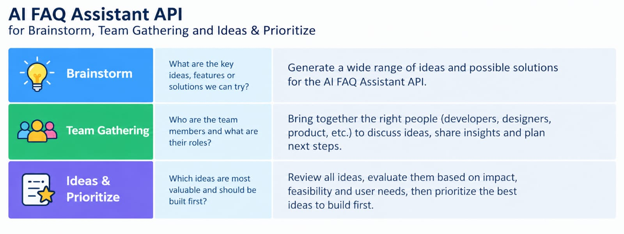
Example:
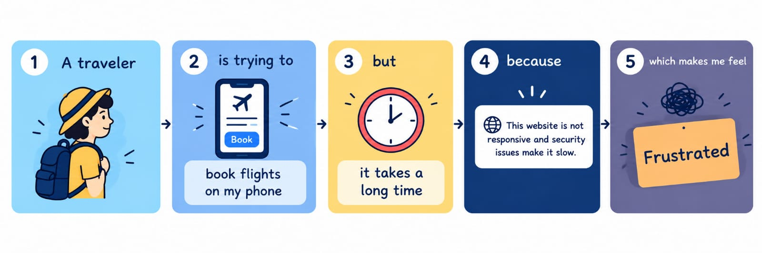
Problem Statement (PS) | I am (Customer) |  | I’m trying to |  | But | Because | Which makes me feel
PS-1 |  | A customer seeking quick support |  | Get answers to my questions quickly | I have to wait for customer support | FAQs are difficult to find and not always easy to understand | Frustrated and confused
PS-2 |  | A customer with a common problem |  | Find accurate information and solve my issue | I receive repeated or irrelevant answers | The existing FAQ system is not personalized or well organized | Unsatisfied and frustrated

